Ticket Designer System User Manual

- Check SQL script in “Database” folder named “TicketDesignerSchema.sql” copy the script and execute it on your own server if you change database name in script it must be reflected on filling your own connection string as described below after “Database=”.

- Second Configure Database connection by accessing DBconfig File in Database folder
- Replace the valued followed by “=” sign localhost with your Server’s name, sa with your user id , Sedc0@123 with your password.

- Open Ticketing Screen Designer.exe

- Login with your bank ID, if bank is not registered yet, Click register and fill the text box with the bank name

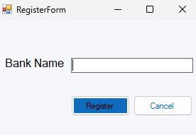
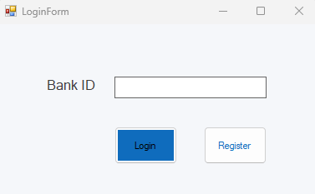

- Always read pop-up messages to get an accurate feedback on your actions and to report issues

- After login A Main form will appear Showing all screens added to the bank

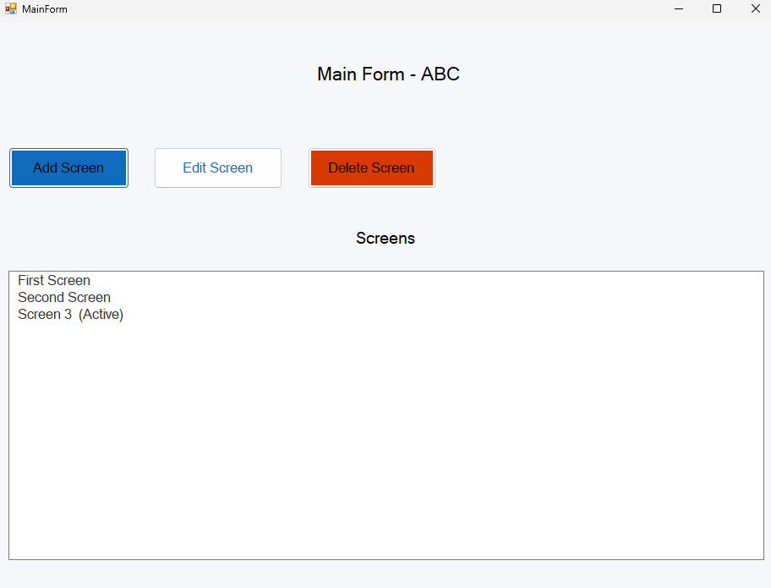

- TO Add a screen Click on add screen button that directs you to Add screen form

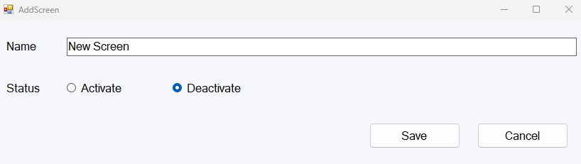

- In order to Add a screen correctly you must fill the name of screen and Click save (you can activate the new added screen by checking activate or leave it as default).

- Click cancel if you want to cancel adding a new screen.

- In order to Delete a screen you need to select one first then Click on Delete Screen to direct

- In order to Edit a Screen you need to select one screen first then Click on Edit Screen to direct into Edit screen form.

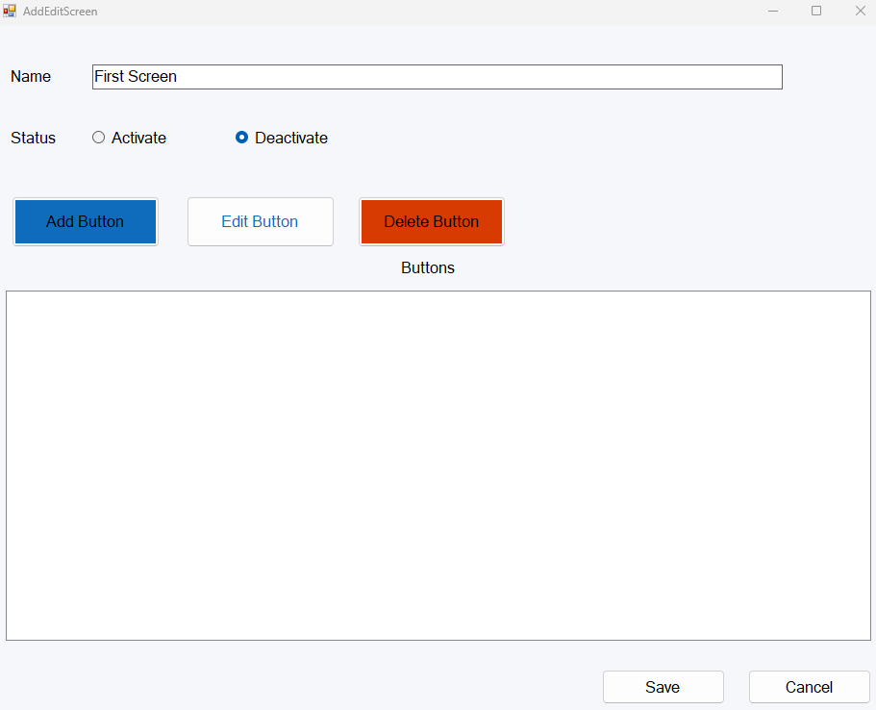

- For edit to take place you must change the active status than original one or the name.

- You can’t activate a screen through edit if another screen is active.

- Click save in order to commit your changes on screen.

- Click cancel if you want to cancel editing the screen.

- In Edit screen you can add, edit, delete buttons in Edit screen Form.

- Click add button to add new button.

- You must fill the button names

- Based on Button action you can choose (Issue a ticket showing types of services) or (Show messages to fill both messages in English and Arabic)

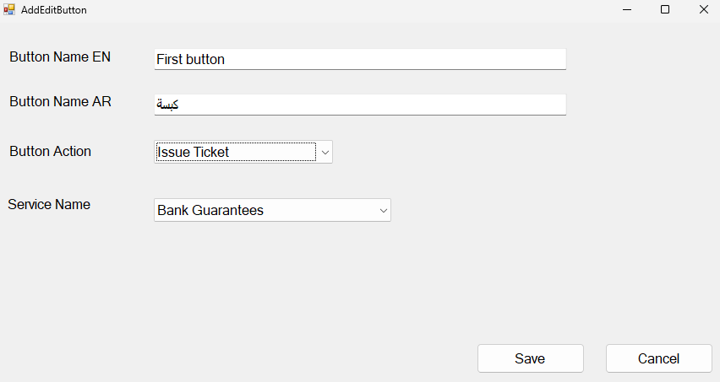

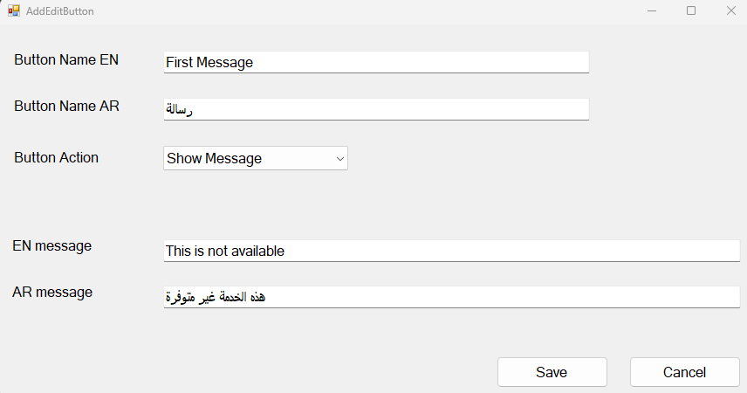
- You can Edit Button Info and change the type (at least one change must take place in order to save and commit changes on button data)

